MVC

When you run your application in MVC >

Request from the browser goes to particular controller. Within that controller, it goes to specific action method, and that action method will decide what to return as a response to the user

By default, this controller is HomeController and action method is Index

Controller : Request Handler

Controller is a class which inherits from Controller Class

Controller has methods which are known as Action Methods

Action methods are public which returns some output

By default its return type is ActionResult

using System;

using System.Collections.Generic;

using System.Linq;

using System.Web;

using System.Web.Mvc;

namespace WebApplicationDemo.Controllers

{

public class HomeController : Controller

{

public ActionResult Index()

{

return View();

}

public ActionResult About()

{

ViewBag.Message = "Your application description page.";

return View();

}

public ActionResult Contact()

{

ViewBag.Message = "Your contact page.";

return View();

}

}

}

First File

Global.asax : File contains some events which are fired

using System;

using System.Collections.Generic;

using System.Linq;

using System.Web;

using System.Web.Mvc;

using System.Web.Optimization;

using System.Web.Routing;

namespace WebApplicationDemo

{

public class MvcApplication : System.Web.HttpApplication

{

**protected void Application_Start()**

**{**

**AreaRegistration.RegisterAllAreas();**

**FilterConfig.RegisterGlobalFilters(GlobalFilters.Filters);**

**RouteConfig.RegisterRoutes(RouteTable.Routes);**

**BundleConfig.RegisterBundles(BundleTable.Bundles);**

**}**

}

}

How to make controller

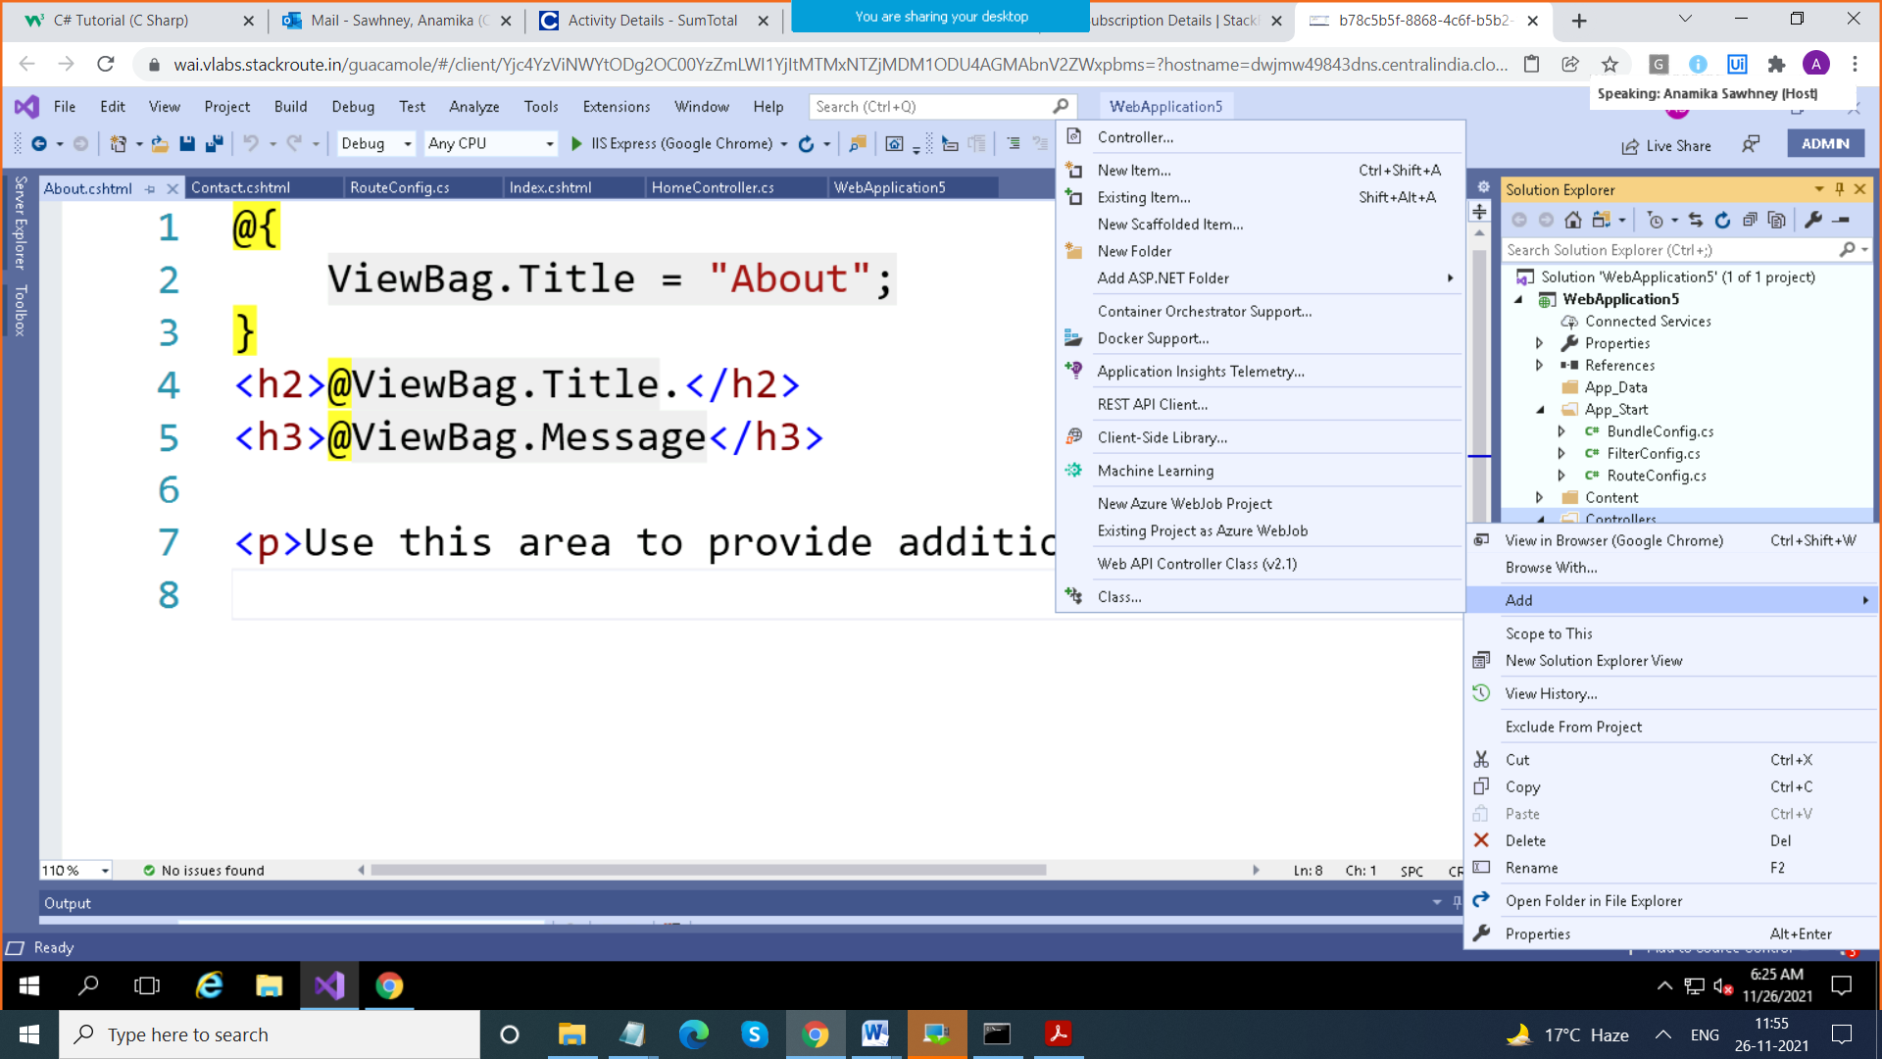

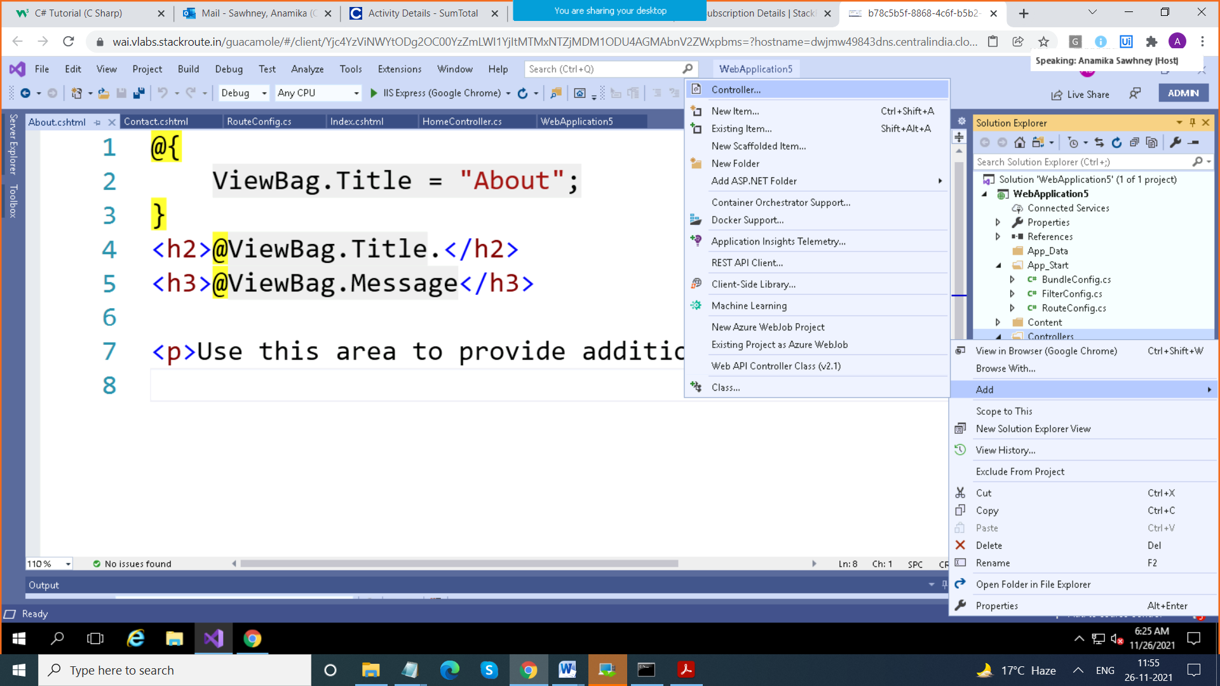

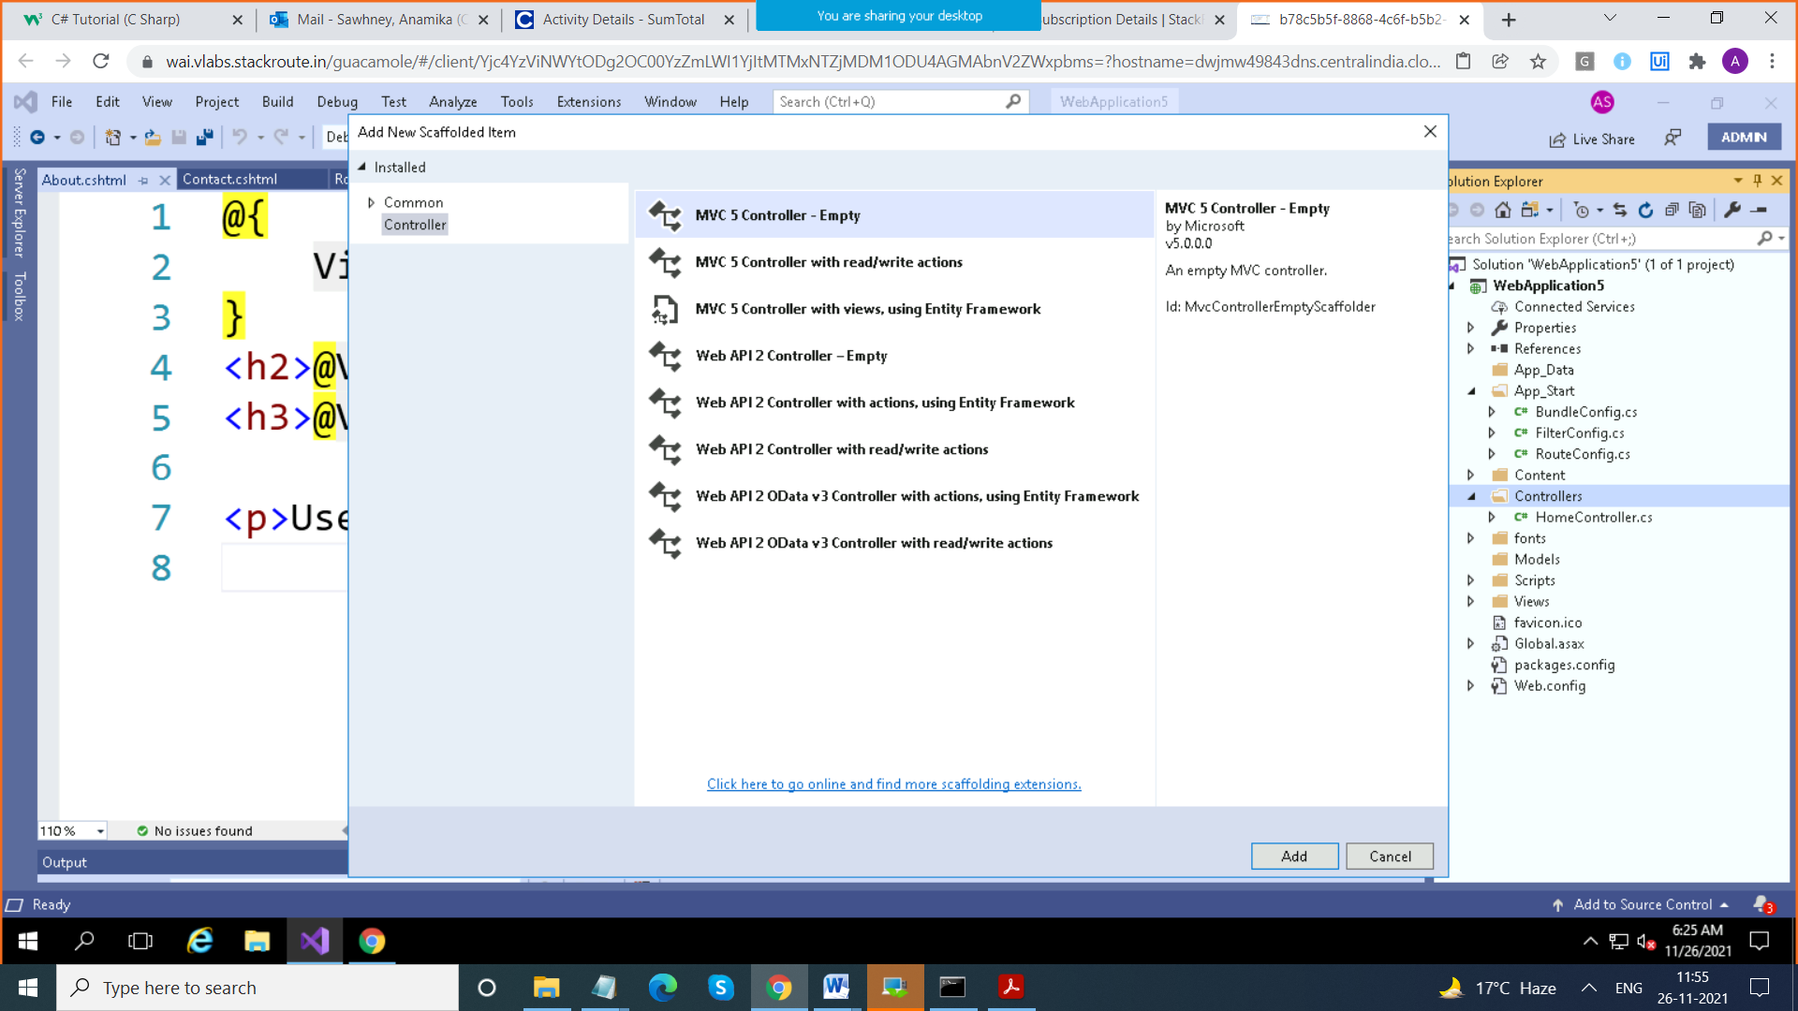

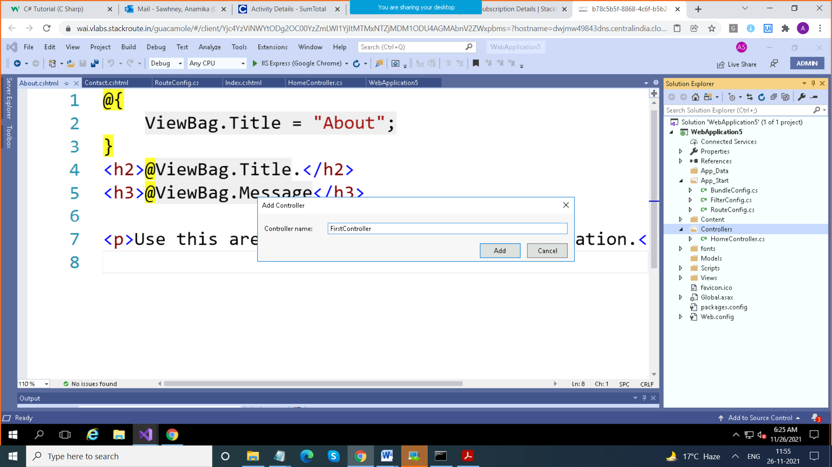

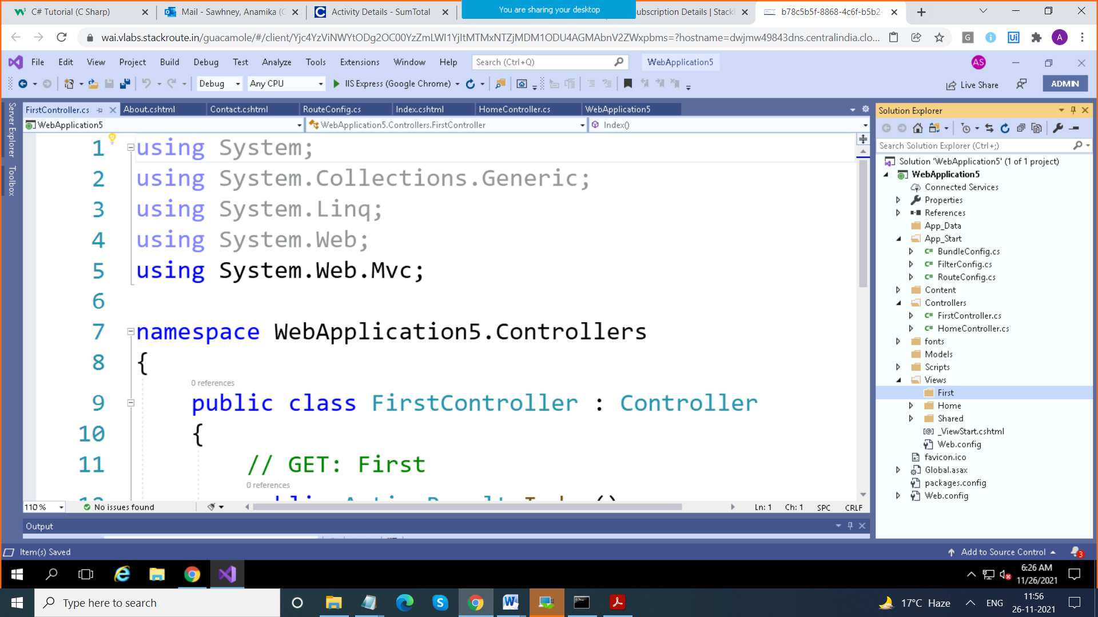

using System;

using System.Collections.Generic;

using System.Linq;

using System.Web;

using System.Web.Mvc;

namespace WebApplication5.Controllers

{

public class FirstController : Controller

{

// GET: First

public ActionResult Index()

{

return View();

}

}

}

How to add View

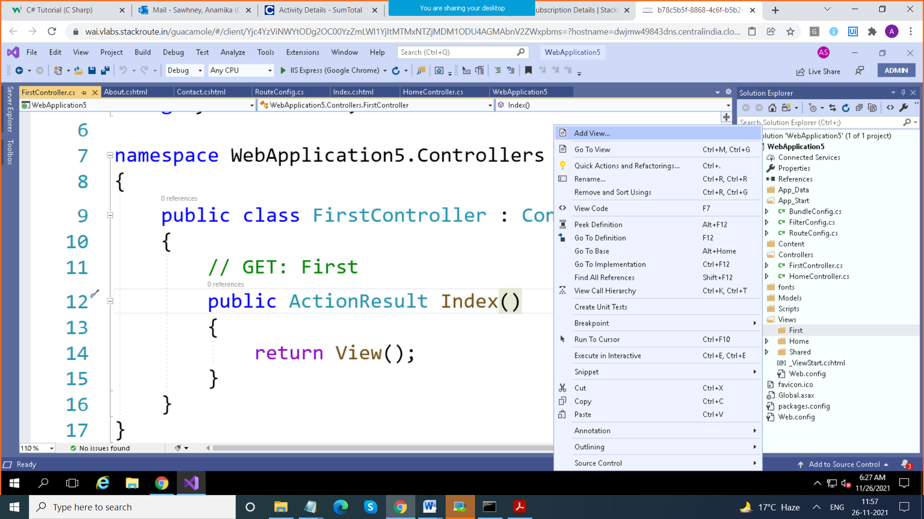

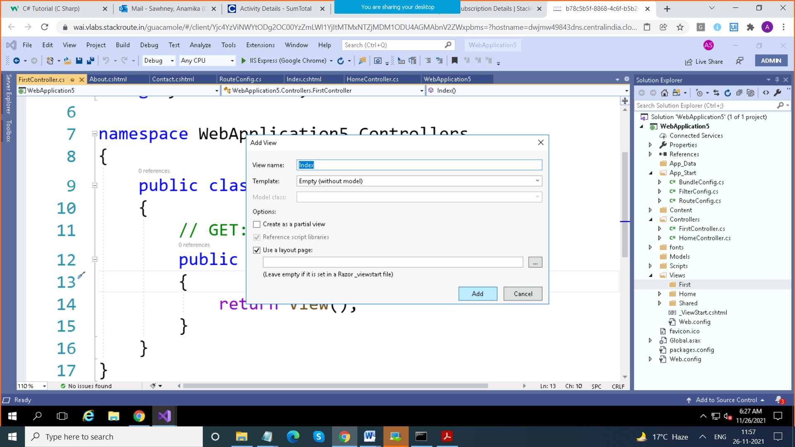

Route that is used is

Protocol://servername:portno/Controller/ActionMethod/Parameters

Localhost:1234 > Home Controller / Index

Localhost:134/First > First Controller / Index

<http://localhost:49839/First/Action1> > First Controller / Action1

<http://localhost:49839/First/Action1>

<https://localhost:44341/First/Method1>

Here https is protocol

Localhost > server , IISExpress

44341 : port no. where IISExpress is running

First > controller Name

Method1 > Action Method Name

public ActionResult Index()

{

ViewBag.data = "hello";

return View();

}

----------------------------------------

@{

ViewBag.Title = "Index";

}

<h2>Index of First Controller </h2>

<h1> @ViewBag.data </h1>

@{

ViewBag.Title = "Index";

}

public ActionResult Index()

{

ViewBag.data = "hello";

ViewBag.Date = DateTime.Now.ToString();

return View();

}

<h2>Index of First Controller </h2>

<h1> @ViewBag.data </h1>

<br />

@ViewBag.Date

-----------------------------------------

Extension of View is .cshtml (Rajor Page)

It can contain HTML markup as well as C# code

Whenever you want to add C# code , we use @

.cshtml pages contain html + server side code also

How to pass Data from Action Method to View

ViewData

ViewBag

ViewBag.data = "hello";